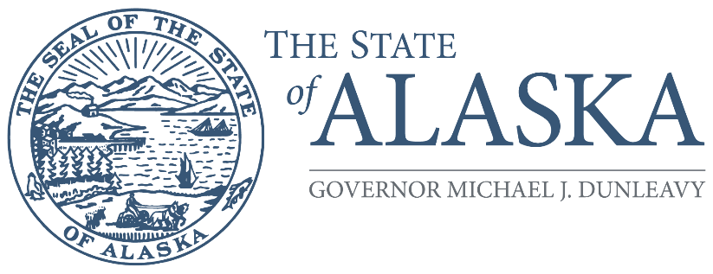
Office of the Governor

COMMISSION FOR HUMAN RIGHTS

800 A Street, Suite 204
Anchorage, Alaska 99501-3669
Main: 907.274.4692 / 907.276.7474
TTY/TDD: 711 for Alaska Relay
Fax: 907.278-8588

FOR IMMEDIATE RELEASE

Alaska State Commission for Human Rights to hold short telephonic meeting on April 17, 2023, at 1:00 pm

March 31, 2023 (Anchorage, Alaska) – The Alaska State Commission for Human Rights is holding a short telephonic meeting on April 17, 2023, at 1:00 pm, primarily to discuss additional recommendations to its current legislative agenda. Specifically, the Commission called on the Alaska Legislature to make some administrative adjustments in statute to the date of its annual report and to change its name to reflect its constitutional mandate more accurately. During legislative meetings in February, additional ideas were proposed to coincide the annual report with the budget cycle, and legislators asked exactly what name the Commission wanted to see. The Commission will also receive a legislative briefing on HB 99, which proposes to create a definition of “sex” that includes gender identity and sexual orientation, thereby granting the Commission explicit statutory jurisdiction over LGBTQ+ complaints. The Commission invites the public to attend the meeting telephonically or via Zoom to listen and provide comment.

The Commission is an independent quasi-judicial state agency that aims to eliminate discrimination and support Alaskans when they face discrimination in the workplace, places of public accommodation, housing, credit and financing, and government practices. The Commission consists of seven volunteers who are appointed by the governor and confirmed by the legislature for rotating five-year terms. The Commission consists of Chairperson Zackary Gottshall (Anchorage), Vice Chairperson Mae Marsh (Fairbanks), William Craig (Sitka), Rebecca Carrillo (Juneau), Jessie Ruffridge (Soldotna), Lonzo Henderson (Anchorage), and Shiela Cernich (Anchorage).

Commission staff is available for assistance directly to the business community, either through speaking engagements to organizations, reviewing non-discrimination policies, or providing copies of its guidance documents which are also available on its website: https://humanrights.alaska.gov/human-rights-commission-annual-reports/. For more information about our agency, please visit https://humanrights.alaska.gov.

To talk about discrimination experiences directly to an investigator, call (800) 478-4692 or (907) 274-4692.

