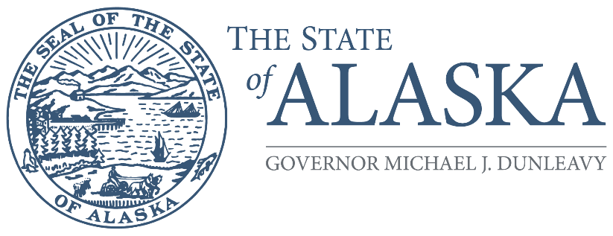
Office of the Governor

COMMISSION FOR HUMAN RIGHTS

800 A Street, Suite 204
Anchorage, Alaska 99501-3669
Main: 907.274.4692 / 907.276.7474
TTY/TDD: 711 for Alaska Relay
Fax: 907.278-8588

FOR IMMEDIATE RELEASE

Alaska State Commission for Human Rights Finishes 2022 Work by Adopting Resolutions at UAF, Meets with Fairbanks Diversity Council

December 16, 2022 (Anchorage, Alaska) – The Alaska State Commission for Human Rights held its final meeting of the year earlier this week at the Wood Center on the University of Alaska Fairbanks campus where it adopted two resolutions calling for greater access to childcare for special-needs children and addressing an administrative timing issue that is prescribed by statute. It also met with the Fairbanks Diversity Council to discuss discrimination priorities in the greater Fairbanks area.

“Parents of young children already have a difficult time finding adequate childcare. Those difficulties are compounded when a child has a disability,” said Commissioner Rebecca Carrillo, who sponsored the childcare resolution. “Parents of these children find there are a limited number of childcare providers with experience or capacity to provide services to children with special needs. As a result, these children do not receive the full range of support they need to thrive in their pursuit of education, posing a barrier to access,” added Carrillo.

According to the resolution, there were 7000 disabled children in Alaska in 2019, and disability rates are highest among American Indian and Alaska Native children.

In total, the Commission adopted seven resolutions during calendar year 2022. In July, it adopted three. The first called on Congress to repeal a federal pay disparity allowing disabled workers to be paid subminimum wages. The second asked the Governor to update the Commission’s name to avoid confusion with broader issues addressed by the United Nations’ Universal Declaration of Human Rights which fall outside the Commission’s function and jurisdiction. The third asked the Alaska Legislature to address a statutory gap where non-profit corporations can avoid discrimination liability before the Commission.

During its October meeting in Sitka, the Commission added two more disability-related resolutions, asking the State to incorporate disability access requirements into public-facing technology such as DMV kiosks, and calling on healthcare providers to provide accommodations for patients with communication-related disabilities who may require additional time during medical appointments.

“As part of an outreach undertaking, the Commission is making an effort to meet in communities throughout the state to educate Alaskans about their civil rights under the Alaska Constitution,” said Zackary Gottshall, Commission Chairperson. “We appreciated the Fairbanks community for hosting us on Tuesday, and we look forward to continuing a dialogue with the Fairbanks Diversity Council.”

The Alaska State Commission for Human Rights is an independent quasi-judicial state agency that aims to eliminate discrimination and support Alaskans when they face discrimination in the workplace, places of public accommodation, housing, credit and financing, and government practices. The Commission consists of seven volunteers who are appointed by the governor and confirmed by the legislature for rotating five-year terms. The Commission consists of Chairperson Zackary Gottshall (Anchorage), Vice Chairperson Mae Marsh (Fairbanks), William Craig (Sitka), Rebecca Carrillo (Juneau), Jessie Ruffridge (Soldotna), and Lonzo Henderson (Anchorage). The seventh seat is currently vacant.

For more information about our agency, please visit humanrights.alaska.gov. To talk to an investigator directly, call (800)-478-4692 or (907)-274-4692.

