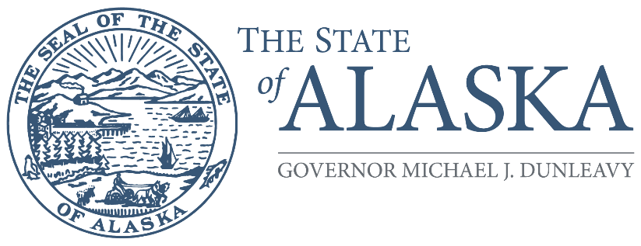
Office of the Governor

COMMISSION FOR HUMAN RIGHTS

800 A Street, Suite 204
Anchorage, Alaska 99501-3669
Main: 907.274.4692 / 907.276.7474
TTY/TDD: 711 for Alaska Relay
Fax: 907.278-8588

FOR IMMEDIATE RELEASE

Alaska State Commission for Human Rights invites Fairbanks-area residents to attend public meeting on Tuesday, December 13, 2022, at the UAF Wood Center conference room EF at 12:30 pm

November 29, 2022 (Anchorage, Alaska) – The Alaska State Commission for Human Rights is holding its next quarterly meeting in Fairbanks on Tuesday, December 13, starting at 12:30 pm on the University of Alaska campus. The meeting will take place at the Wood Center in conference room “EF.” The Commission invites the public to attend the meeting to listen and provide comment. In addition, staff will host an informational booth beginning at approximately 10:00 am to take discrimination complaints and provide resources to business owners, human resources professionals, and individual Alaskans to educate them about their rights.

This is the second meeting of an expanded outreach effort the Commission is personally undertaking to re-engage with Alaskans in 2022. The first took place in Sitka on October 17, with outreach during the community’s Alaska Day festivities. Holding these as hybrid meetings with most Commissioners participating remotely allows the agency to remain cost-sensitive while still expanding awareness about civil rights and the agency’s services.

The Commission is an independent quasi-judicial state agency that aims to eliminate discrimination and support Alaskans when they face discrimination in the workplace, places of public accommodation, housing, credit and financing, and government practices. The Commission consists of seven volunteers who are appointed by the governor and confirmed by the legislature for rotating five-year terms. The Commission consists of Chairperson Zackary Gottshall (Anchorage), Vice Chairperson Mae Marsh (Fairbanks), William Craig (Sitka), Rebecca Carrillo (Juneau), Jessie Ruffridge (Soldotna), and Lonzo Henderson (Anchorage). The seventh seat is currently vacant.

In addition to holding meetings in communities, the Commission recently undertook outreach to much of the alcohol service industry to help avoid disability discrimination complaints related to service animals. It also advertised its services through a statewide radio campaign last summer. The Commission set up informational booths at the Kenai Peninsula State Fair, the Alaska State Fair, the Anchorage Juneteenth Celebration, the Pride Rise & Shine Education Fair, and during the Alaska Federation of Natives Annual Convention. Staff also held a “lunch & learn” during the Elders & Youth Conference and provided training to the Alaska State Troopers Academy.

Commission staff is available for assistance directly to the business community, either through speaking engagements to organizations such as Rotary clubs, reviewing non-discrimination policies, or providing copies of its guidance documents which are also available on its website: https://humanrights.alaska.gov/human-rights-commission-annual-reports/

For more information about our agency, please visit https://humanrights.alaska.gov. To talk about discrimination experiences directly to an investigator, call (800)-478-4692 or (907)-274-4692.

