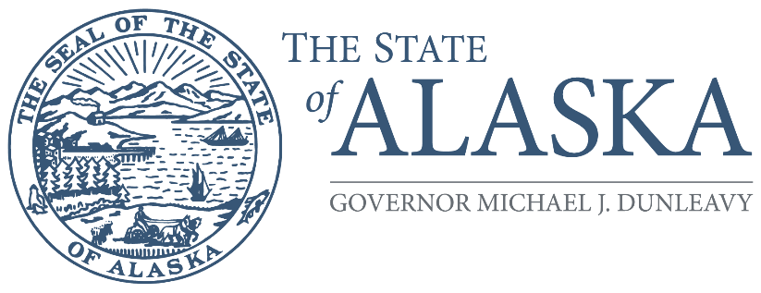
Office of the Governor

COMMISSION FOR HUMAN RIGHTS

800 A Street, Suite 204
Anchorage, Alaska 99501-3669
Main: 907.274.4692 / 907.276.7474
TTY/TDD: 711 for Alaska Relay
Fax: 907.278-8588

RESOLUTION 2022-5

WHEREAS, the State of Alaska regularly procures technology with interfaces for the public, such as registration kiosks at the Division of Motor Vehicles, voting tablets used by the Division of Elections, and computer terminals set up for the public at some Department of Labor locations; and,

WHEREAS, the state’s Americans with Disabilities Act Compliance Program’s policy statement provides that “no qualified individual with a disability shall be excluded, by reason of such disability, from participation in or be denied the benefits of the service, programs, or activities of a state agency; or be subjected to discrimination by any such agency;” and,

WHEREAS, AS 18.80.255 makes it unlawful for the state “to refuse or deny to a person any local, state, or federal funds, services, goods, facilities, advantages, or privileges because of physical or mental disability;” and,

WHEREAS, the state’s procurement officers do not always consistently consider accessibility when soliciting and purchasing hardware and software that requires a public interface.

NOW, THEREFORE, BE IT RESOLVED, that the Alaska State Commission for Human Rights calls on the Governor to notify all State of Alaska procurement officers and other state employees with purchasing authority to consider accessibility for those with physical or mental disabilities, as is required by state policy and state statute, when procuring technology that requires a public interface.

Copies of this resolution shall be forwarded to the Office of the Governor and all members of the Alaska Legislature.

ADOPTED at Sitka, Alaska, this ___ day of _________, 2022

____________________________________
Zackary Gottshall
Chairperson
Alaska State Commission for Human Rights

I hereby certify that the foregoing Resolution
2022-5 is a true and accurate copy of the
language adopted by the Commission on
___________________, 2022.

____________________________________
Angela Park
Secretary
Alaska State Commission for Human Rights

